Practical 3

# Initial settings. Add a user. Network Settings, Change to static IP address, Disable IPv6 if not needed, Configure Services, display the list of services which are running, stop and turn OFF auto-start setting for a service if you don't need it, Sudo settings.

**Step 1:** Add a user.

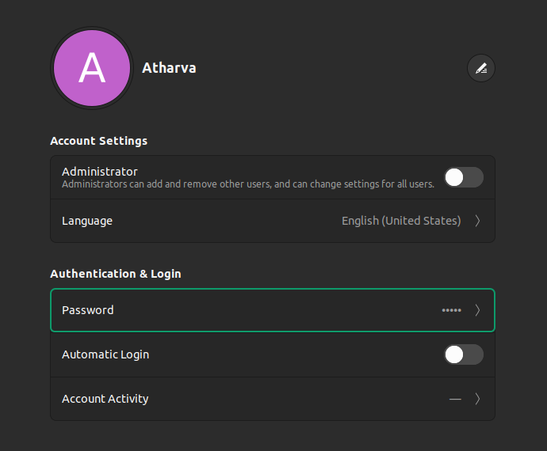

**Step 2:** Change to static IP address

To assign a static ip address to a Ubuntu system, you need to edit the etc/network/interfaces file.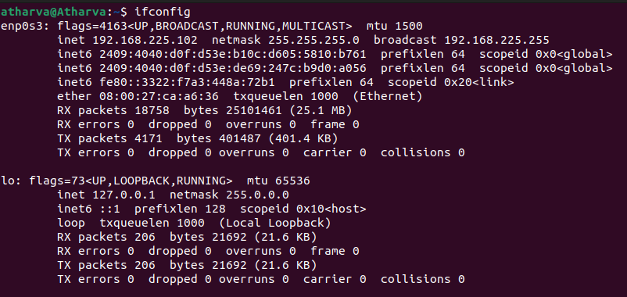

Now copy down the ip address and netmask from the output of ifconfig command into a notepad, to find out the gateway ip address type the following command.

ip r | grep default



Copy them as follows in a notepad.

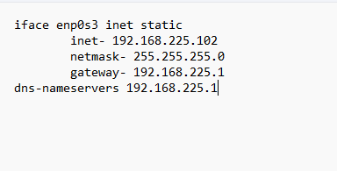

**Step 3:** Now editing the static IP address, for that you'll need the following command.

sudo nano /etc/network/interfaces

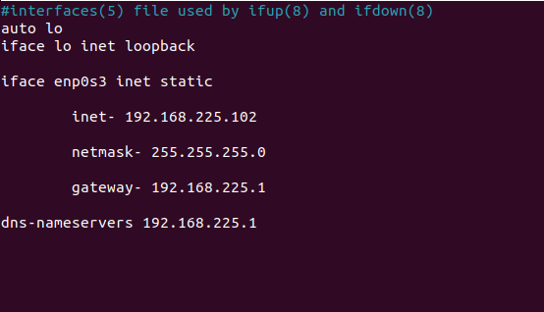

**Step 4:**

**Step 5:** Now after editing your static IP address you should reboot your machine.

**Step 6:** Now we will disable the IPv6 if not needed. That can be done using the following command:

sudo /bin/su -c ”echo ‘net.ipv6.conf.all.disable_ipv6-1’>>/etc/sysctl.conf”



**Step 7:** Now to show the list of multicast address we will use the following command.

ipmaddr

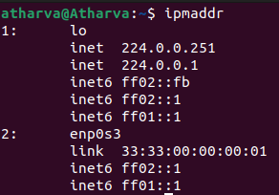

**Step 8:** Now we will display the list of services which are running and have been stopped. Which will be done using the following command.

systemctl -t service

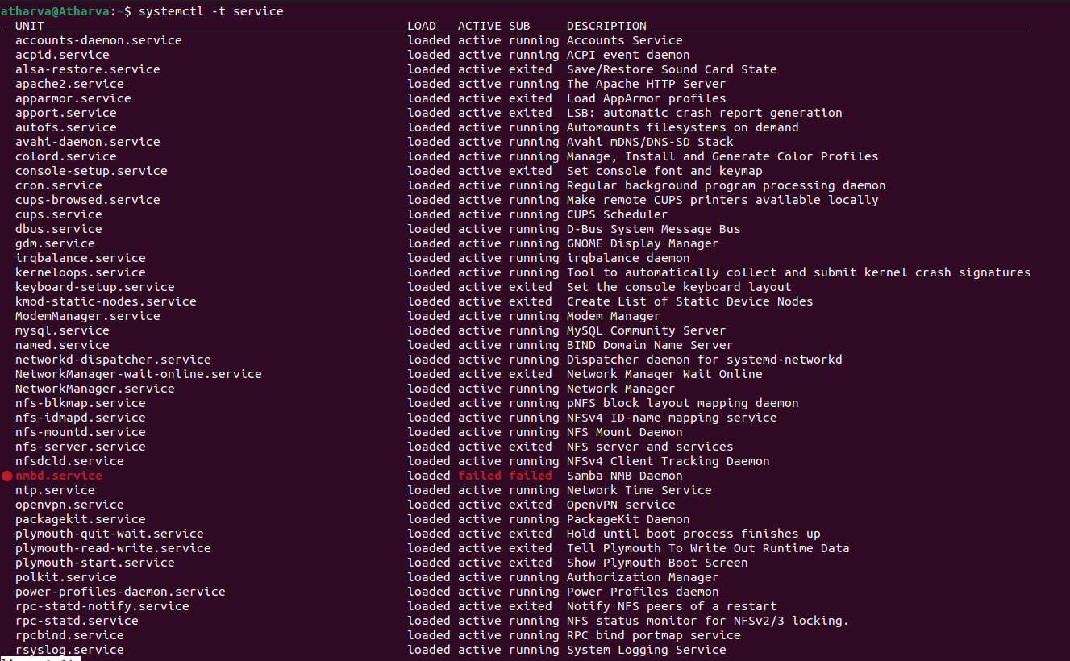

**Step 9:** Now we will stop the apparmor service from the list of services which can be done by using following command.

Systemctl stop apparmor

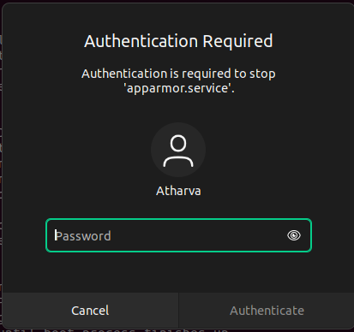

**Step 10:** After stopping the apparmor service will be disable it using the following command.

Systemctl disable apparmor

